**REMOTE CONTROL TOWER FANS:**

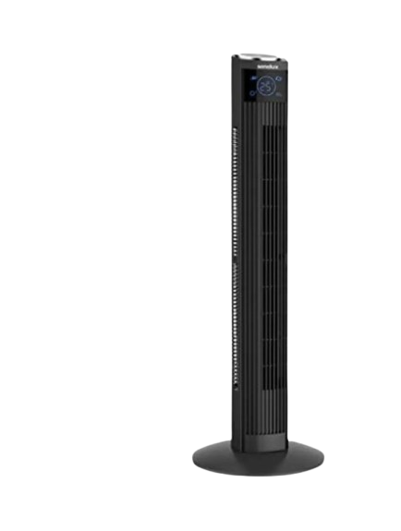

**Price: 10,500.00**

The Remote Control Tower Fan is a convenient and modern cooling solution, designed to provide effortless temperature control from anywhere in the room. With its sleek and compact remote control, you can easily adjust fan speed, oscillation, and timer settings without getting up. Its slim tower design, quiet operation, and energy-efficient motor make it perfect for bedrooms, living rooms, and offices, offering a comfortable and relaxing atmosphere with the touch of a button.

**Key features of remote control tower fans include:**

* **Remote Control**: Convenient control from a distance.
* **Multiple Speed Settings**: Adjustable airflow for comfort.
* **Oscillation**: Even air distribution across a wide area.
* **Slim Design**: Space-saving and compact.
* **Quiet Operation**: Low noise for a peaceful environment.